# **9 Realistic Methods for Recession-Proofing Your Small Business**

***Do you need help getting your business finances in order for tax season? Let the de-tax professionals at Individualized Systems get you organized and ready to file.*** [***Contact us today to set an appointment***](https://indivsys.com/) ***with our experienced team.***

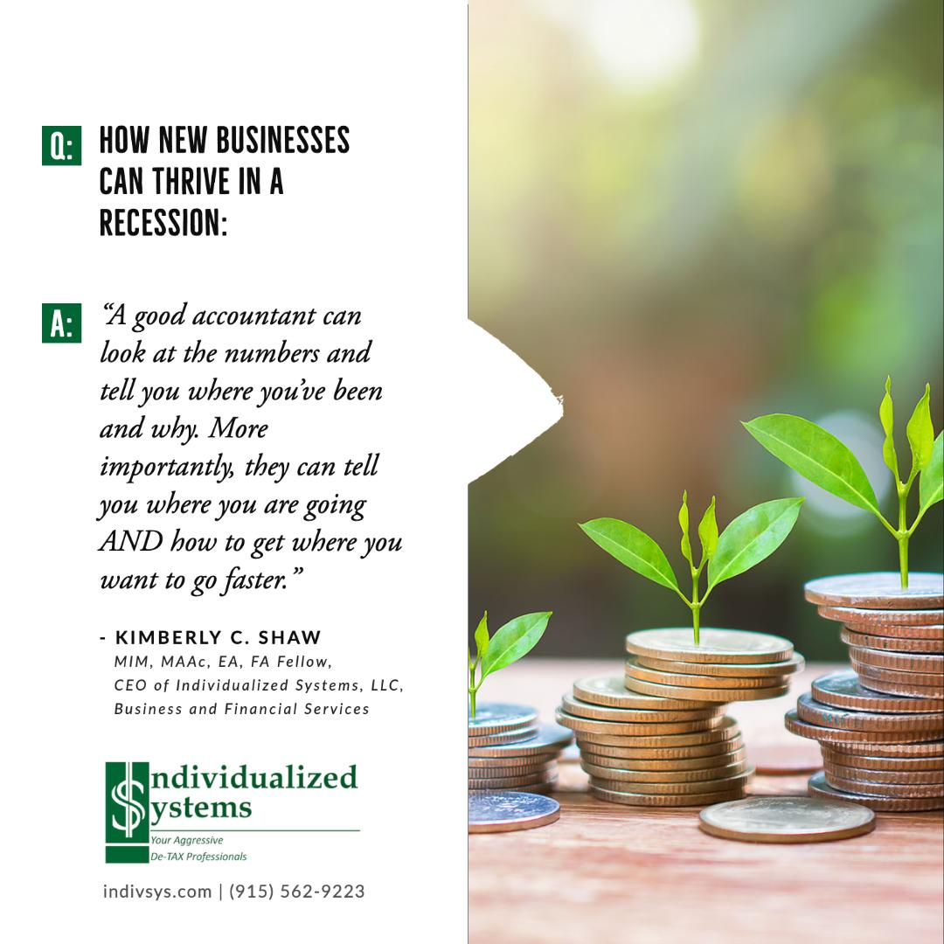

As a small business owner, you may be feeling anxious about the state of the economy. Will a recession hit? And if it does, will your business be able to survive?

There's no need to panic. While recessions are certainly daunting, there are steps you can take to ensure your business stays prepared. By taking proactive measures now, you can weather any economic storm that comes your way.Below are nine ways to recession-proof your small business:

## **1. Reassess Your Legal Structure**

One of the best ways to recession-proof your small business is to [reevaluate your legal structure](https://www.sba.gov/business-guide/launch-your-business/choose-business-structure) with your accountant or financial advisor. If you're not currently operating as an LLC, now may be the ideal time to make the switch. An LLC offers many benefits, including protection from personal liability and tax flexibility. With an LLC, you can choose how you want to be taxed, saving you a lot of money in the long run.

Many entrepreneurs and small business owners discover it worth the investment to hire a formation service to establish their LLCs. Not only can a formation service save you time and stress, but it's also less expensive than hiring a law firm. To learn [how to start an LLC in Texas](https://www.zenbusiness.com/texas-llc/), visit a well-reviewed formation service’s website to see what the process entails. You will need to provide them with important information, like your business name and registered agent, but they will complete the paperwork for you.

## **2. Modify Your Business Strategy**

If you want your business to survive a recession, you must have a solid business strategy in place. Unfortunately, many small businesses don't take the time to develop a strategy and instead operate on instinct. This can be a recipe for disaster during tough economic times.

If you haven't already done so, it's time to sit down and [assess your current business strategy](https://www.vistage.com/research-center/business-leadership/strategic-planning/20181105-10-steps-building-best-business-strategies/). It is best to include your accountant or financial advisor. You should discuss questions like, are you doing everything possible to maximize profits? Are you making smart decisions about expenses? Could your strategy use some improvement?

## **3. Review Your Expenses and Cut Costs Where Possible**

Take a close look at your business expenses and see where you can trim the fat. Can you negotiate better rates with vendors? Are there any unnecessary expenses that can be eliminated? Cutting costs now will [give you some breathing room](https://connecteam.com/how-to-reduce-business-costs/) if revenue declines during a recession. It is best if you conduct this process with a professional accountant who can review your financial information with you. They will also be able to identify income increase opportunities and expense reduction areas.

## **4. Build Up Your Savings and Create a Rainy Day Fund**

It's always a good idea to have some financial cushion, but it's especially critical during uncertain economic times. You can work through the best strategies for your business with your accountant or financial advisor so that you can start stashing away money now. That way, if you need it, you will have a reserve to fall back on. You can create a rainy day fund by:

* Putting a percentage of your profits into savings each month
* Asking customers to prepay for goods or services
* Setting up a line of credit with a bank or lender

## **5. Make Sure Your Marketing Budget Is Tight and Focused**

Marketing is essential for keeping your business afloat during tough times, but that doesn't mean you should throw money at every marketing opportunity that comes your way. Be strategic with your marketing spend and focus on activities that will [provide the greatest ROI](https://mailchimp.com/marketing-glossary/roi/). Here are a few tried-and-true, cost-effective marketing strategies:

* **Develop a strong social media presence.** This is one of the most cost-effective methods for reaching your target market.
* **Utilize email marketing.** Email is an excellent way to [stay in touch with customers](https://blog.hubspot.com/marketing/email-marketing-guide) and promote special deals and discounts.
* **Create informative blog content.** Well-written, informative articles and blogs will show potential customers that you're an expert in your field.
* **Get involved with community events.** Getting involved with local events will help you promote your business while building relationships with potential customers.

Once you have reviewed your possibilities and chosen a few that you believe are best for your business, run the financial aspects by your accountant or financial advisor. It’s best to ensure that you are investing your money wisely before you make any financial commitments.

## **6. Manage Your Business and Financial Records**

Maintaining accurate and up-to-date business and financial records is critical for any small business. If you need to find financing or assistance during a recession, you'll need to provide accurate information about your business operations. This means ensuring your records are organized, current, and easy to access, which is why you should [find an experienced accountant in your area](https://indivsys.com/choosing-your-tax-preparerfinancial-consultant/) who you can trust. Their guidance and recommendations will make them an important partner in your financial success.

One way to ensure your records are in good shape and that you can easily share them with your accountant is to use an extract PDF tool. This tool can help you [quickly and easily extract critical data](https://pdf.iskysoft.com/pdf-form/pdf-data-extraction.html) from your documents, making it easy to compile reports or provide information to lenders or other interested parties.

## **7. Diversify Your Customer Base**

Relying too heavily on one or two big clients can be dangerous during an economic downturn. If those clients start cutting back on their spending, it could have a major impact on your bottom line. To protect yourself, diversify your customer base and ensure you're [not too reliant on any single client](https://www.fnbo.com/insights/2021/small-business/how-to-safeguard-your-business-by-diversifying-your-customer-base/) for revenue. Keep your accountant or financial advisor in the loop as you make these changes. They can help to guide you through the financial logistics of your choices.

## **8. Beef Up Your Security Measures**

As a small business owner, it's crucial to take steps to beef up your security measures. This will [help protect your business from theft](https://techvera.com/5-tips-for-improving-cybersecurity-at-your-business/), vandalism, and other types of crime. Install security cameras, use security software on your computers, and keep your premises locked down at night. Some of these measures are more expensive than others, so discuss larger investments with your accountant or financial advisor. They may have witnessed other businesses go through this process and have strategies that you can apply as you increase your security, so that you get the best security for the cost.

## **9. Stay Positive**

One of the most important things you can do during tough times is to stay positive. Keep your chin up and focus on the future. Remember that recessions don't last forever, and your business will eventually rebound.

## **Make a Plan to Weather the Storm**

The best way to prepare for a recession is to take proactive measures now to ensure your business is as strong as possible. Evaluate your legal structure, build up savings, be strategic with marketing spend, and follow the other tips listed above. Then, your company will be equipped to weather any storm that comes your way and come out even stronger on the other side.

**For more Recession advice, please visit:**

<https://recession.biz/>